**ArgoUML Installation Guide**

**Notes:** *This freeware installer already malfunctioning due to the Java 1.6 JRE no longer available during installation process. This document will guide you how to manually install this software to Windows 10.*

Follow the following steps:

1. This software requires Java 1.6 or higher (So far tested up to Java 1.8) to be installed on the target computer. If you already have Java 1.6 or Higher on your computer, you may skip this step. Otherwise, go to <https://www.oracle.com/java/technologies/javase/javase-jdk8-downloads.html> to download JDK8 (32 or 64 bits), and perform standard installation.
2. Go to course website <https://20483.azurewebsites.net/> to download AlgoUML.zip file.

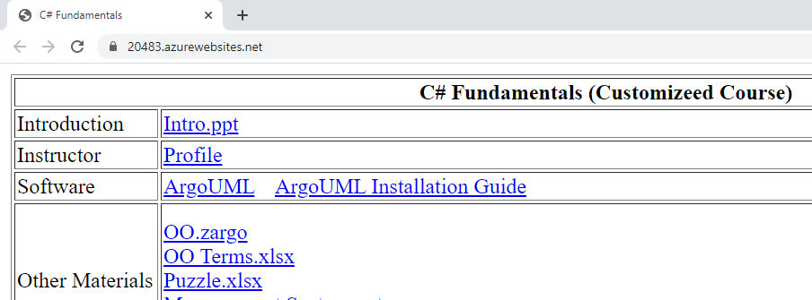

1. Navigate to the download folder, right click the ArgoUML.zip file and select **Extract All…**

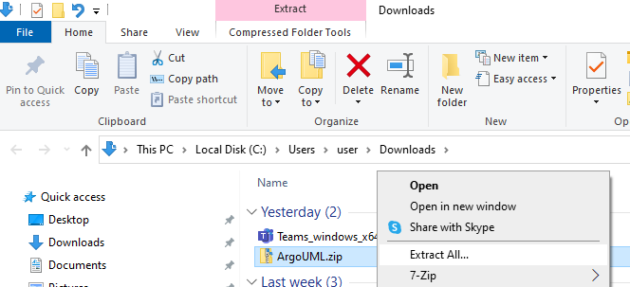

1. Extract it to “C:\Program Files (x86)” folder.

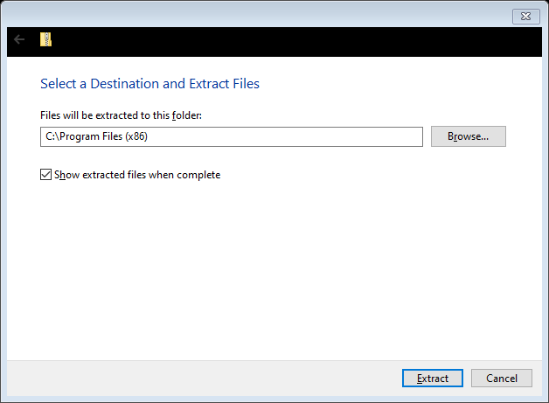

1. Right click at the desktop to create a new shortcut.

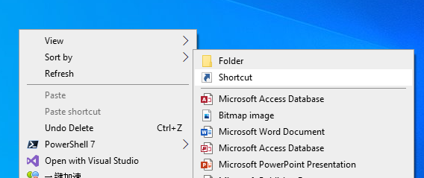

1. In the Create Shortcut dialog box, browse to javaw.exe file, then click **Next** button.

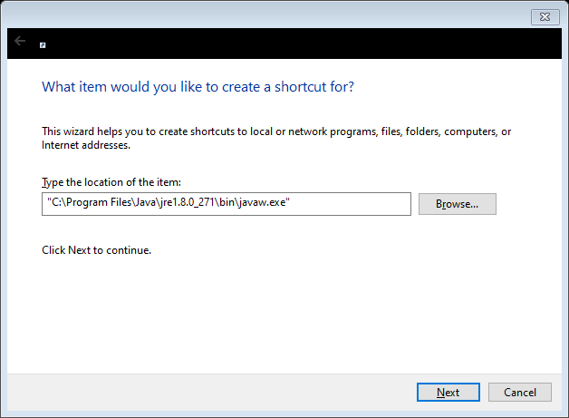

1. In the next page of Create Shortcut dialog box, type the name of this shortcut, then press **Finish** button.

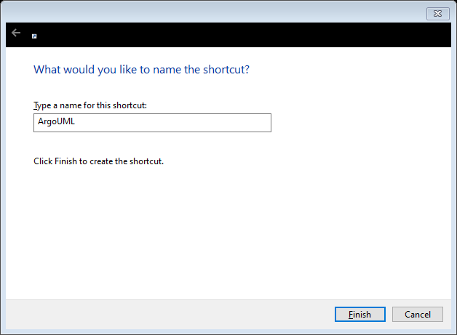

1. Verify that a new shortcut icon created at the desktop.

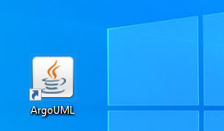

1. Right click the newly created shortcut icon to change the properties.

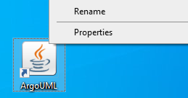

1. In the ArgoUML Properties dialog box, under **Shortcut** tab, change the following:

|  |  |
| --- | --- |
| **Property** | **Value** |
| Target | "C:\Program Files\Java\jre1.8.0_271\bin\javaw.exe" -Xms64m -Xmx512m -jar "C:\Program Files (x86)\ArgoUML\argouml.jar" |
| Start in | "C:\Program Files (x86)\ArgoUML" |
| Comment | ArgoUML 0.34 - UML Modelling tool |

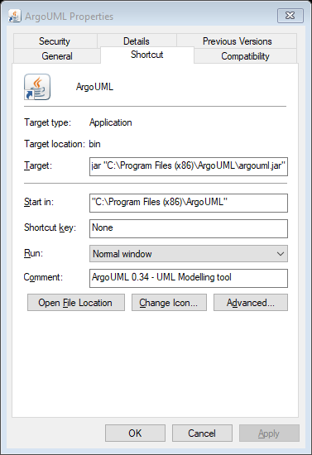

1. While still under the **Shortcut** tab, select the **Change Icon…**

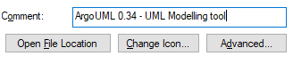

1. Under the Change Icon dialog box, browse to “C:\Program Files (x86)\ArgoUML” to locate for the icon file ArgoUML.ico. Select the icon file followed by pressing button **Open**.

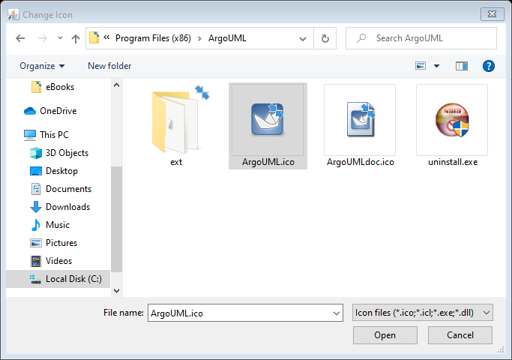

1. Back to Change Icon dialog box, you will see that the icon changed. Now select OK

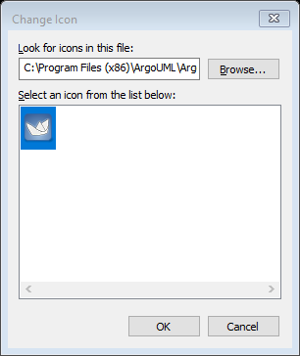

1. When back to ArgoUML Properties dialog box, select Apply.

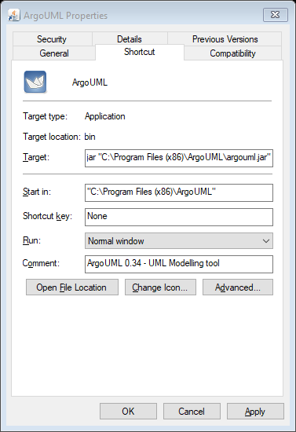

1. Select **OK** to end the Property setting. Now the shortcut icon setting at desktop is done.

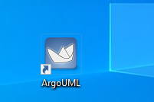

1. Close ArgoUML. Go to course website to download a sample zargo file. This file is compressed in OO.zip. You need to extract it after download.



1. You can double click the shortcut icon to launch the ArgoUML for test.

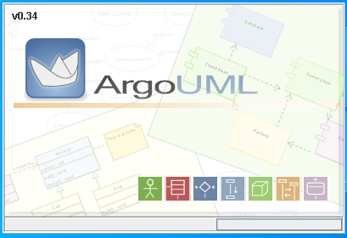

1. You can open the newly download OO.zargo file from ArgoUML.

